Name: Jiahui Wu

ID: 2670210

CIS 660 Lab #1

Description: Feature selection, data preprocessing and transformation and dissimilarity

**Summary**

The software used in this lab are my SQL server, RStudio and Eclipse.

Table of contents

**Part1: Feature selection, cleaning and preprocessing to construct a data source as input**

1-1. create view vTargetBuyerMailList

1-2. create view VTargetBuyers

1-3. Determine the data value type of selected features

1-4. Get grouping info using SQL language

**Part2: Data Preprocessing and Transformation**

2-0. R setup for max lines, work directory, data dimension, null checking

2-1. Attribute Age: data binning; barplot; mean/median/variance/sd

2-2. Attribute YearlyIncome: normalization; histogram; data grouping; mean/median/variance/sd

2-3. Attribute CommuteDistance: data replacement; barplot; mean/median/variance/sd

2-4. Attribute HouseOwnerFlag: barplot; 5-number summar/variance/sd

2-5. Attribute NumberCarsOwned: barplot; 5-number summar/variance/sd

2-6. Attribute NumberChildrenAtHome: barplot; 5-number summar/variance/sd

2-7. Attribute Region: piechart

2-8. Attribute EnglishOccupation: peichart

2-9. Summary of mean, median, variance and sd in part2

2-10. Export transformed data from R to .txt file.

**Part 3. Dissimilarity Calculation**

3-1. Euclidean distance for Age, YearlyIncome, CommuteDistance (interval-scaling first)

3-2. Hamming distance, Jaccard distance and Jaccard similarity for Homeownerflag, region and EnglishOccupation

3-3. Cosine similarity for NumberCarsOwned and NumberChildrenAtHome

Appendix

Java code for calculating mean/median/variance/sd of grouped data

Screen shot of Files and codes titles

**Part1: Feature selection, cleaning and preprocessing to construct a data source as input**

1-0. see all the customer data in the view by select * from vTargetMail

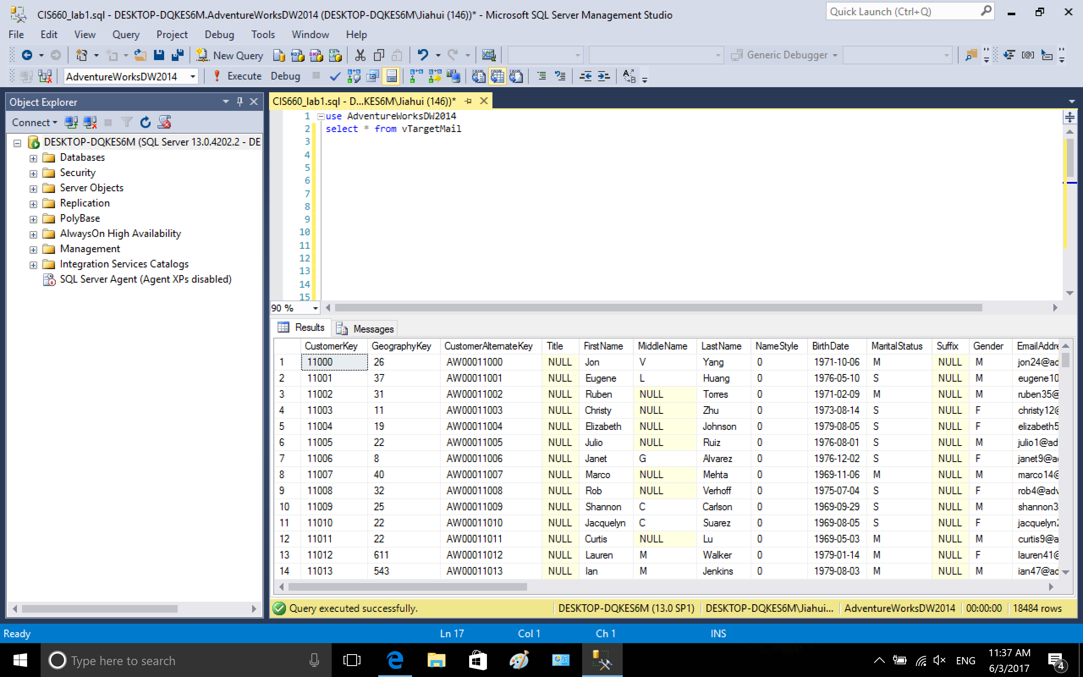

1-1. create view vTargetBuyerMailList, select customerKey as ID for future mapping, select FirstName, MiddleName, LastName and EmailAddress for mailing info. Select 8 attributes to predict future bike buyer, which are: Age, YearlyIncome, CommuteDistance, HouseownerFlag, NumberCarsOwned, Region, EnglishOccupation.

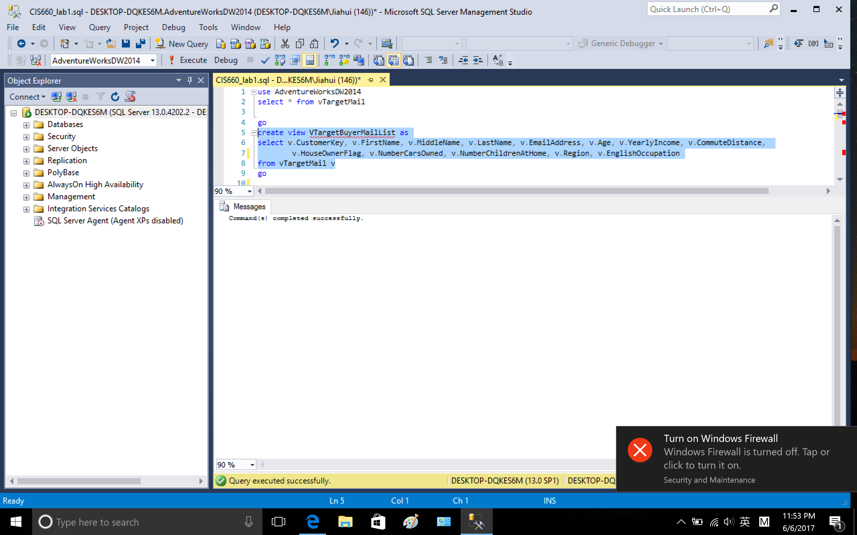

View vTargetBuyerMailList

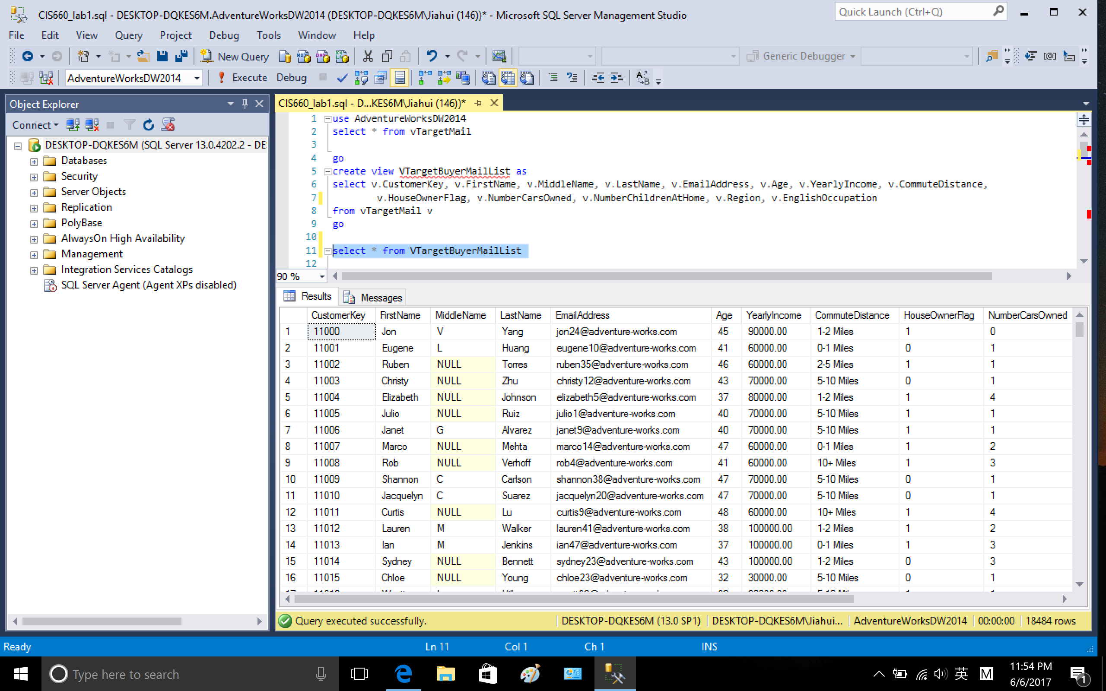

1-2. create a new view named VTargetBuyers from view VTargetBuyerMailingList, the new view has 8 attributes which will be used for prediction.

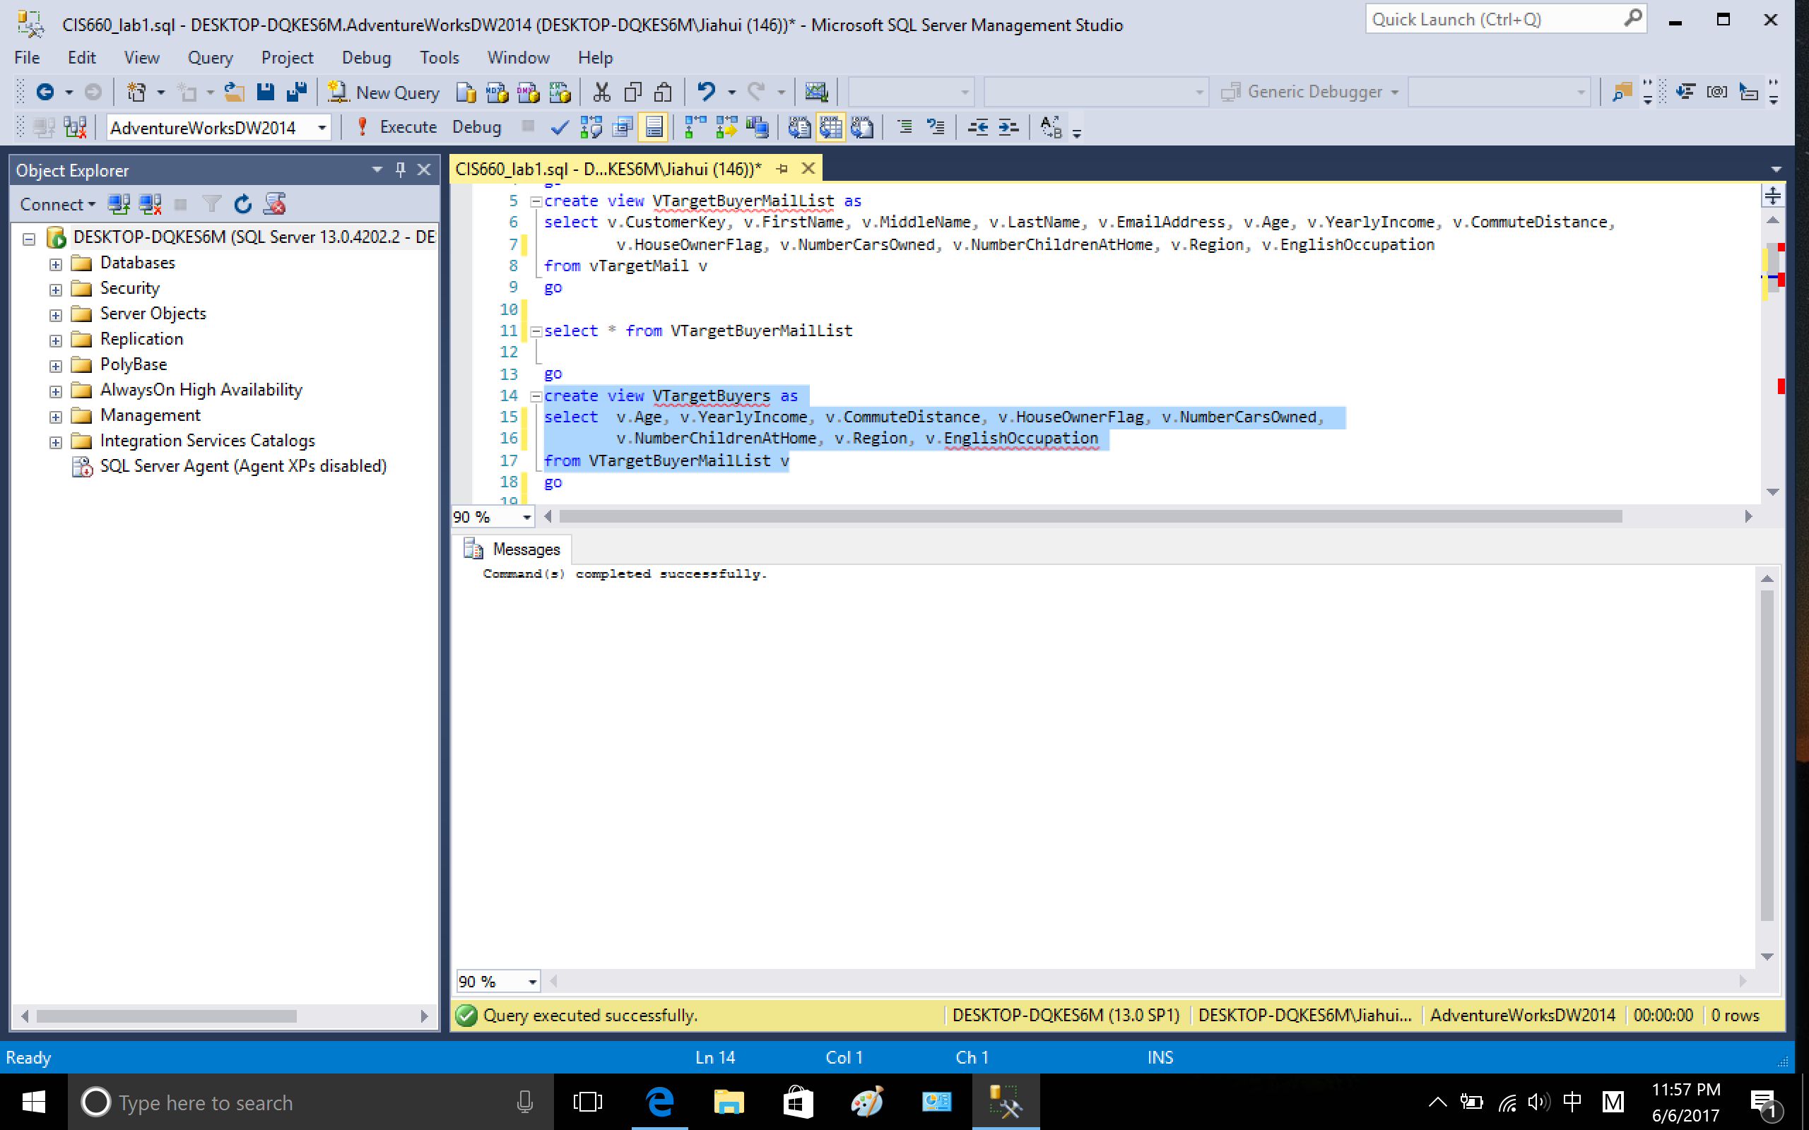

view VTargetBuyers

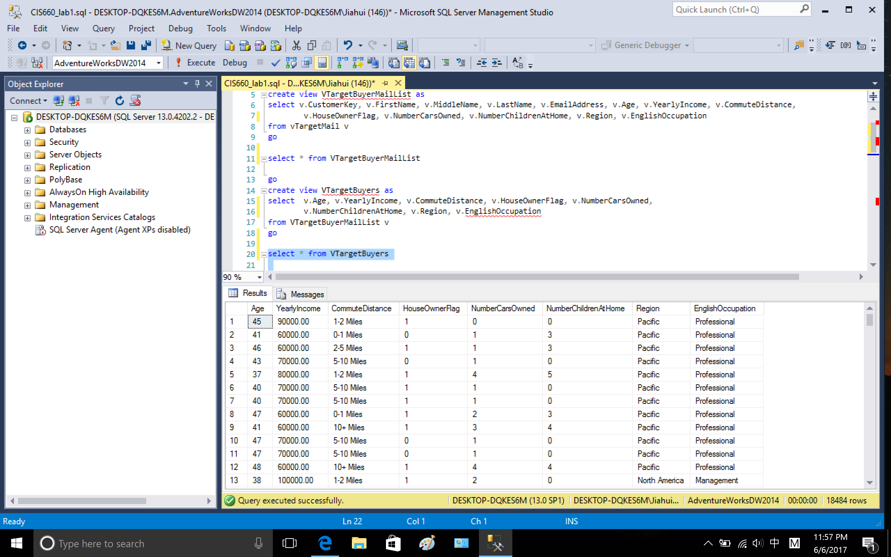

copy to table with header to excel and save as VTargetBuyers.csv

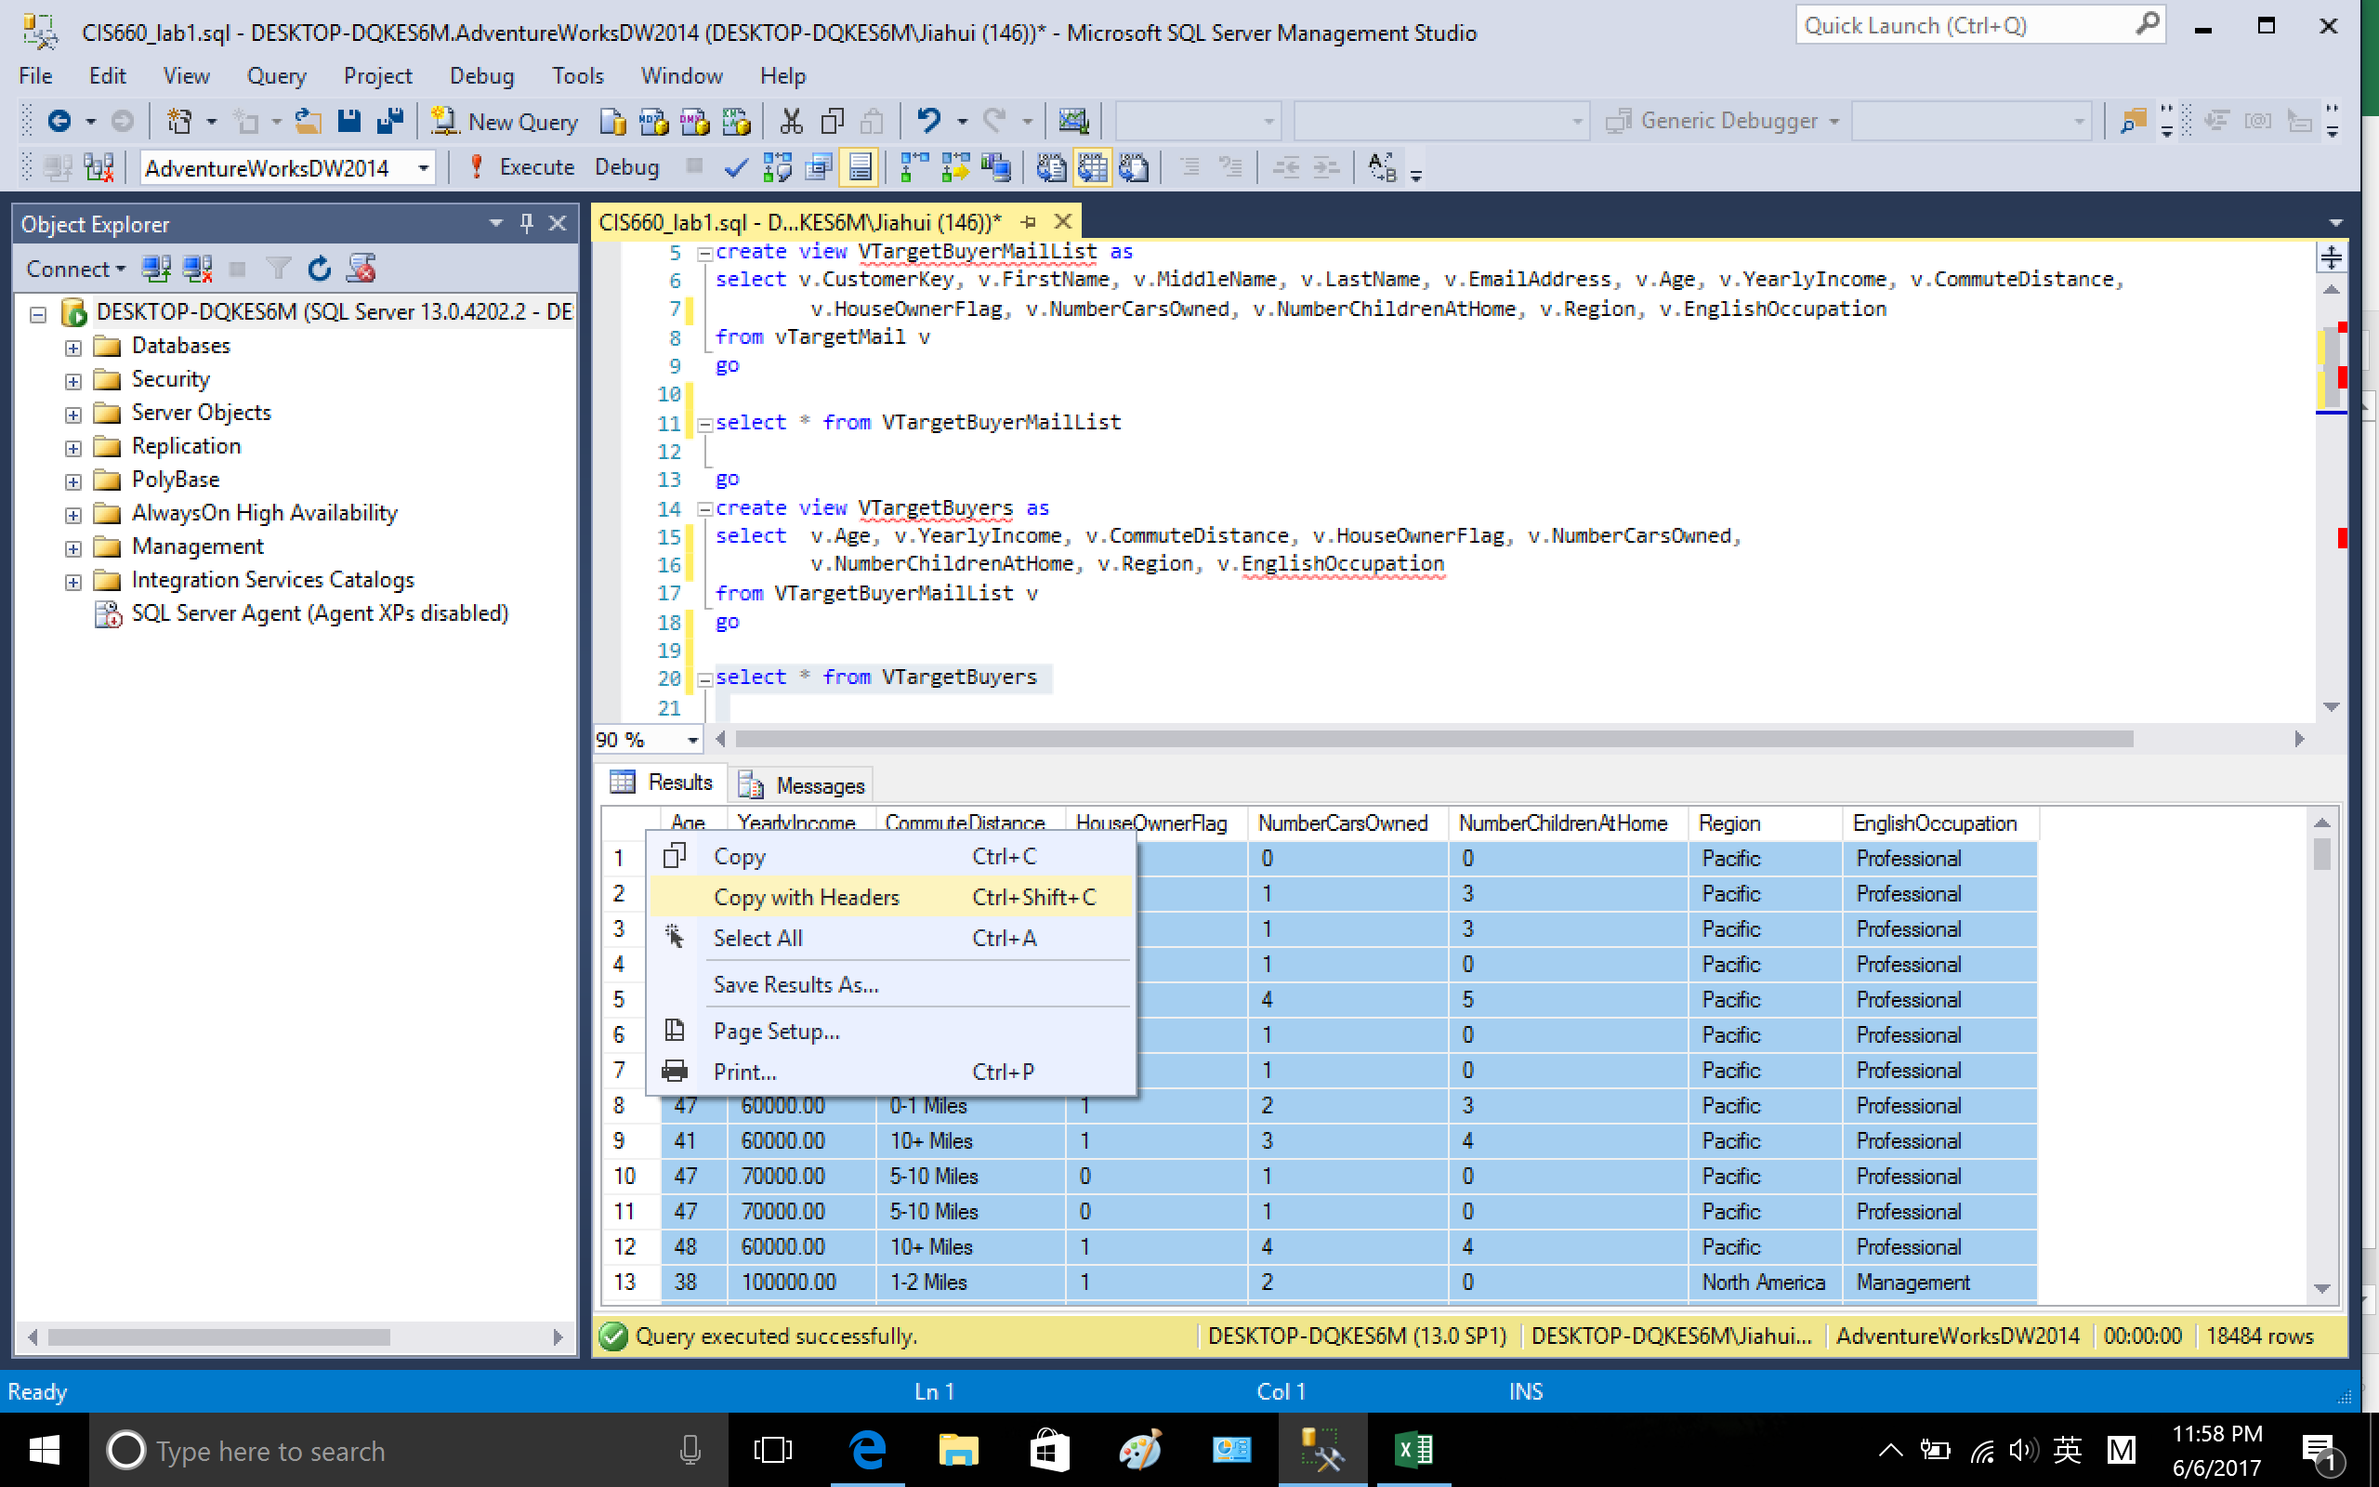

1-3. Determine the data value type of selected features

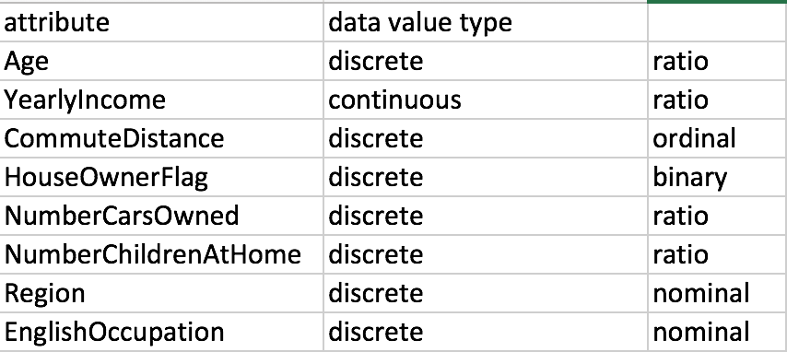

1-4. Grouping each attribute using select attributeName, count(*) from VTargetBuyers grouping by attributeName, export the grouping info into excel for reference so that we can have a brief idea.

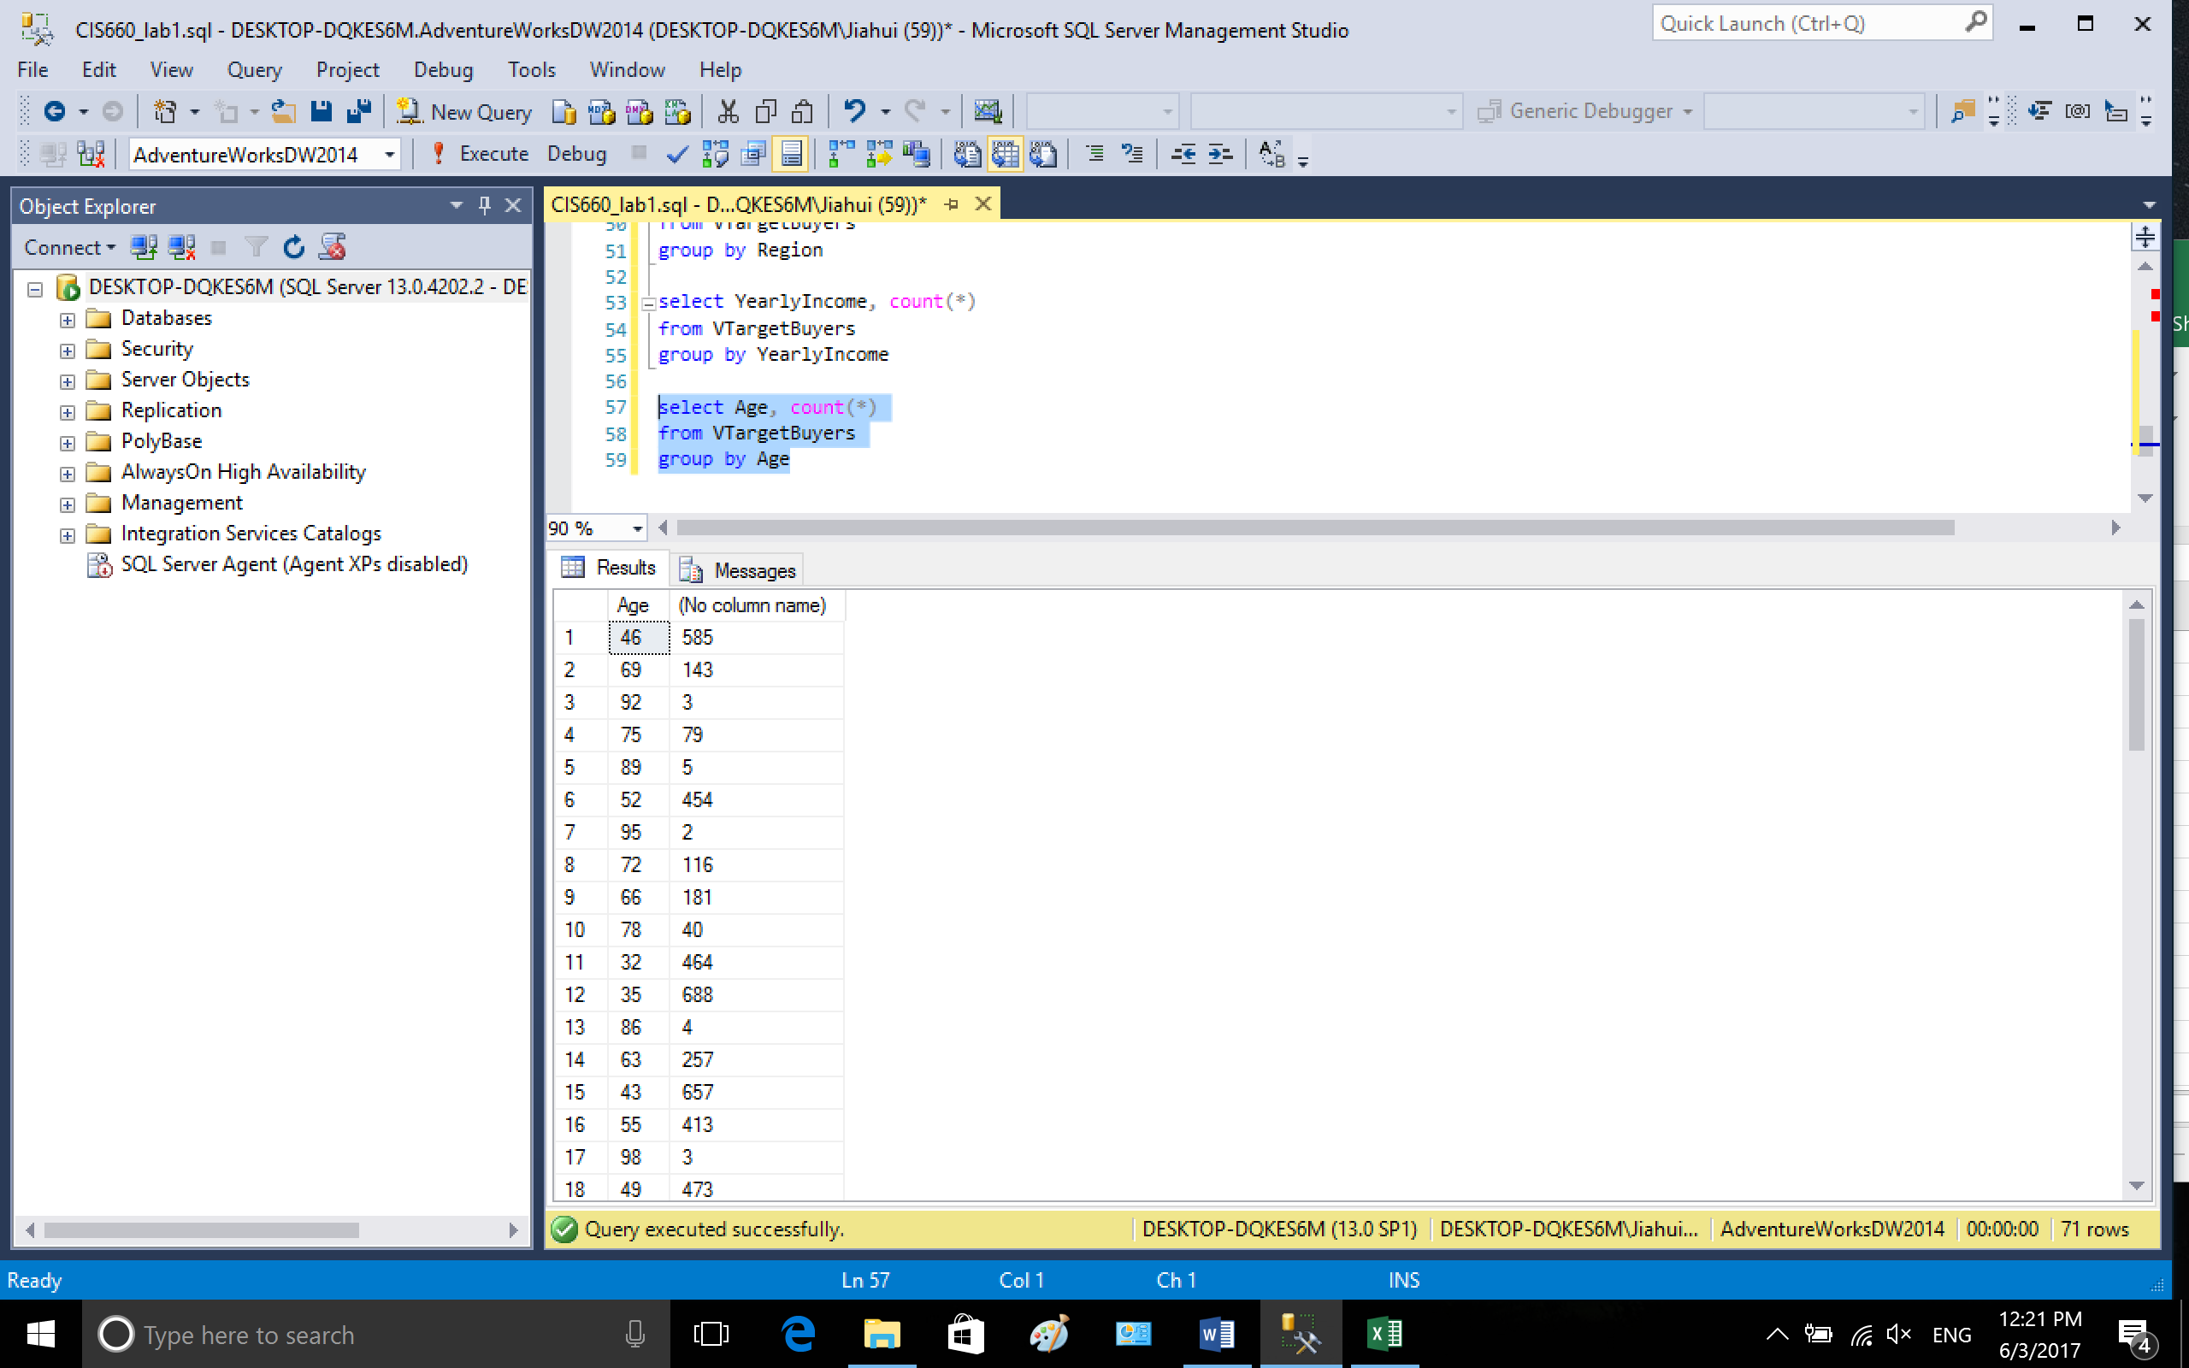

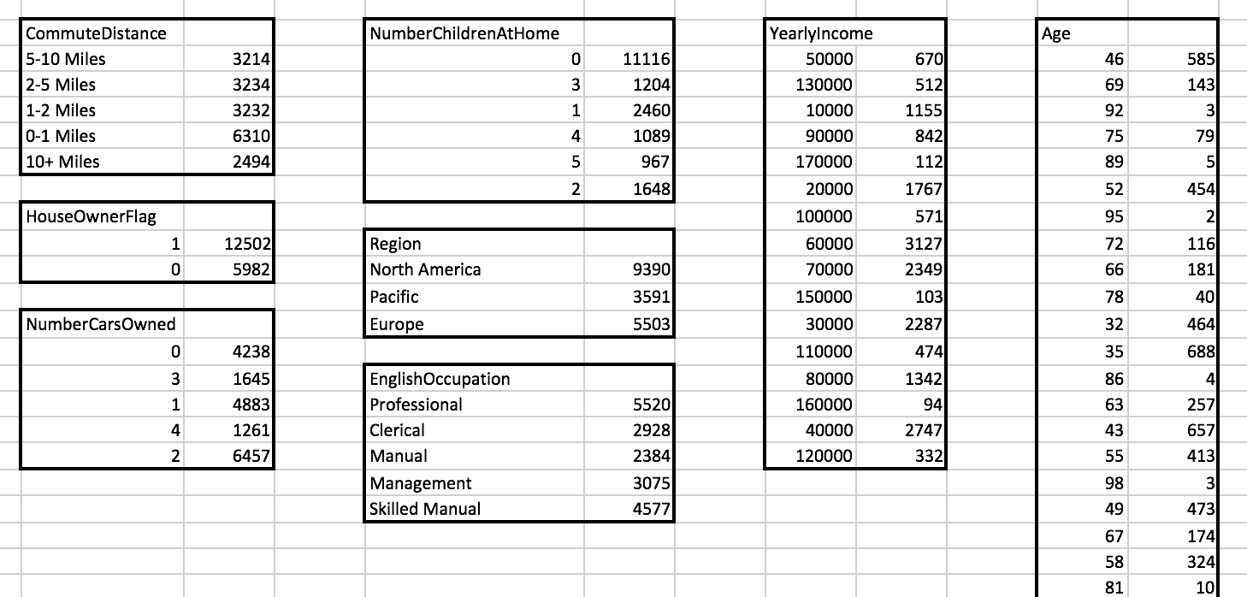

**Part2: Data Preprocessing and Transformation**

I use RStudio to preprocess and transform data.

2-0. set the word directory to the folder where VTargetBuyers.csv was saved



set capacity to 100,000 rows



read data from file



get the dimension of data1, there are 18484 rows and 8 columns

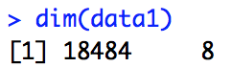

check if there is null data in data1, there is no null data

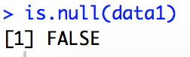

The screen shot display data in R

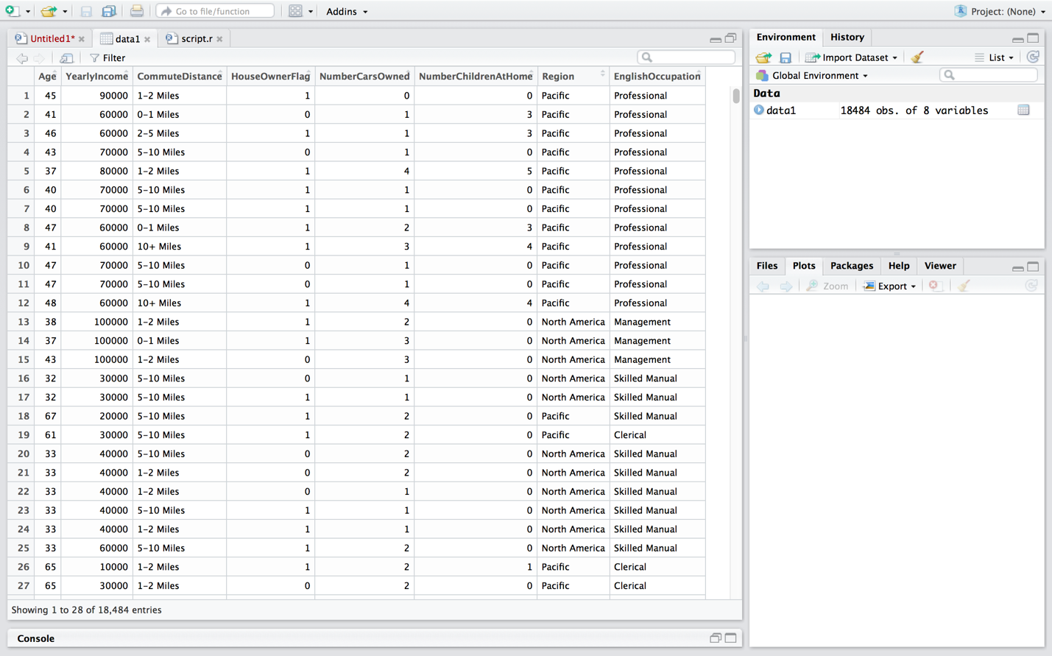

2-1. Attribute **Age**. Age is a discrete and ratio feature, however, there are too many finite numbers in Age, so I use **data binning** to process the values of Age attribute.

**2-1-1. data binning**

According to the previous grouping info, age of buyers ranges from 30 – 101, data frequency is very low above 70. I set specific values for different ranges of age:

30-39 -> 30

40-49 -> 40

50-59 -> 50

60-69 -> 60

70-101 -> 70

From age 30 to 102, combine every 10 different age in one.

I use cut() to split the ages and save the grouped ages in a vector named cuts

Breaks cut at specific value and label names each group within a certain range

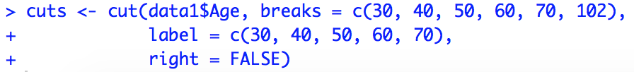

replace Age with values in cuts

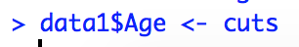

values in Age before and after replacing

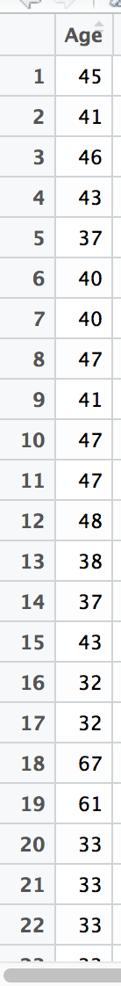 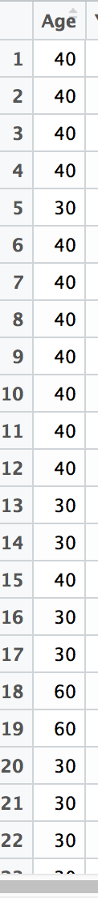

**2-1-2. Plotting Age using barplot, define the name, xlabel, ylabel and color of the plot.**



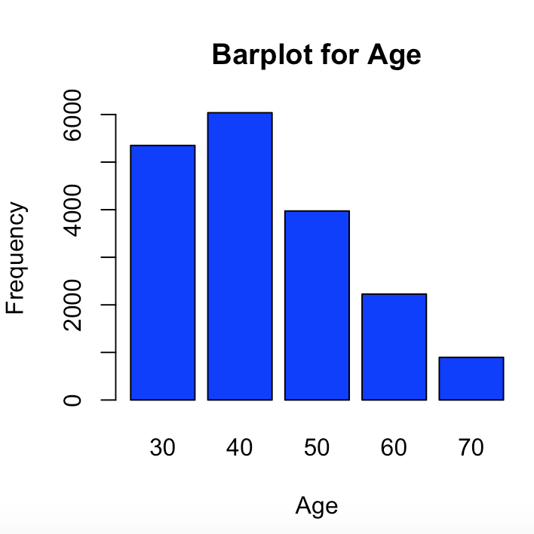

**2-1-3. calculate median, mean, variance and standard deviation for Age.**

Create java function to calculate median, mean, variance and standard deviation for grouped data. I use the following formula to calculate the four parameters.

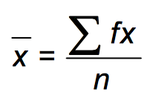 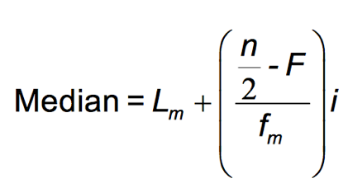 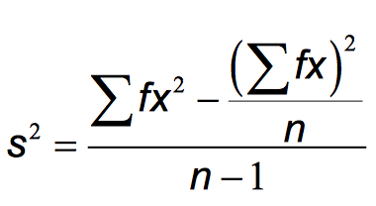 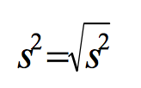

Even though Age is NOT grouped data, we can use the same function to calculate mean, variance and standard deviation because the formula used are the same (not for median), the only thing to note is that the input of lower bound and upper bound are the same for age.

To calculate the values, the table of frequency is as following:

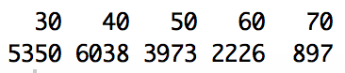

so the input data is:

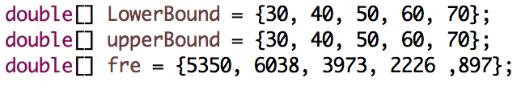

The result is as following. The mean age is 43. Variance is 132.56 and standard deviation is 11.51. (The code is attached in appendix)

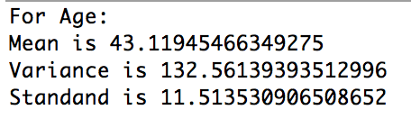

We can easily calculate the median of age by dividing the total 18484 by 2, we got 9242, according to the cumulative frequncy:

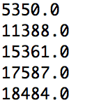

it is in the 2nd class, so the median age is 40.

2-2. Attribute **YearlyIncome**. YearlyIncome is continuous and ratio data, and the data discrepency is really big. So I first nomalize the data, then use data binning to discretize data.

**2-2-1. Normalization**. I use formular (x - min)/(max - min) to normalize data to range 0-1

x = column “YearlyIncome”,

a = minimum value in yearly income

b = maximum value, Function(x) = (x - a) / (b - a).

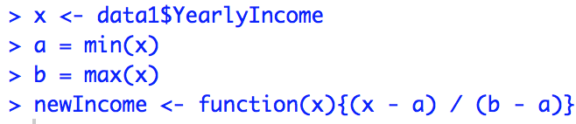

After getting the new vection fun, I replace the column YearlyIncome with new values

data1[2] =column number 2

2 = column



We can see the yearly income before and after normalization

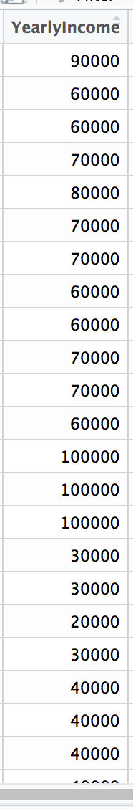 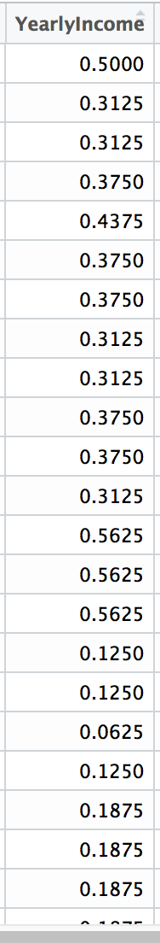

**2-2-2.** **Plotting YearlyIncome using histogram, define the name, xlabel, ylabel and color of the plot.**

Show the yearly income in histogram



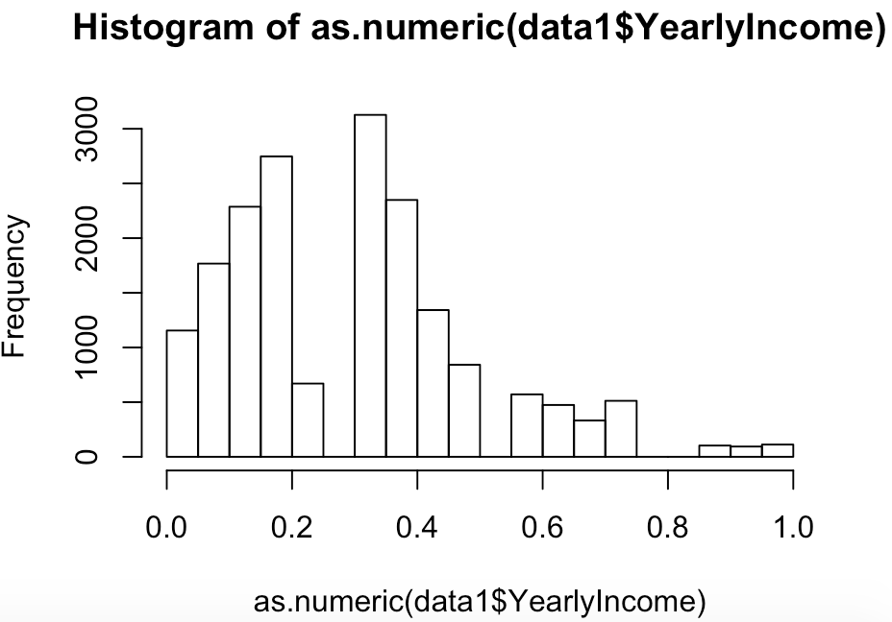

There are still too many columns in the histogram, I combined the income by interval of 0.2



histogram of yearlyIncome

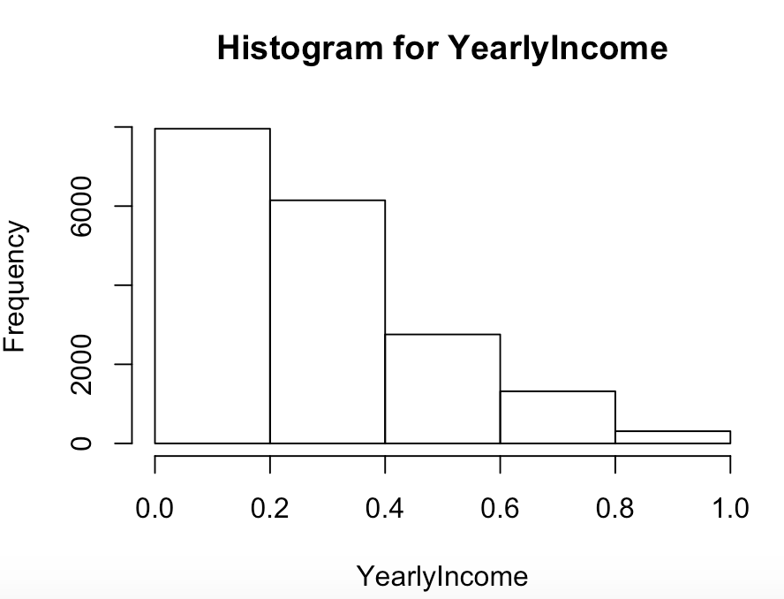

**2-2-3. calculate median, mean, variance and standard deviation for YearlyIncome.**

Yearly income is grouped data, I used the java functions mentioned in 2-1. First, to get the info of input, I got the lowerBound, upperBound and frequency (counts) from the histogram.

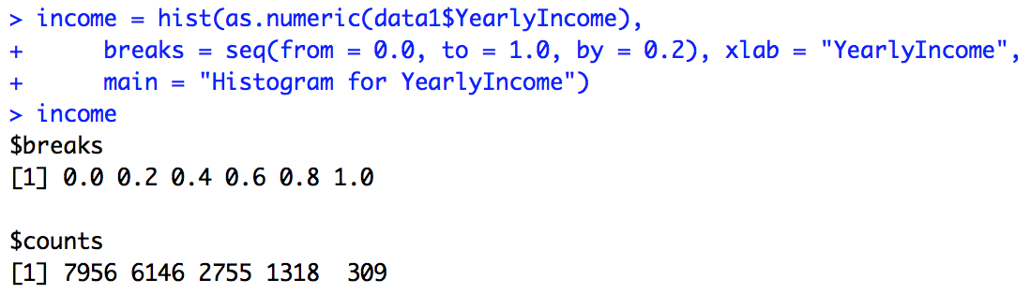

So the input is

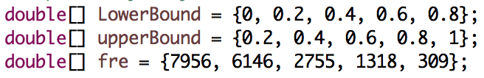

and output is

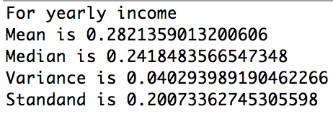

For normalized data of yearly income, the mean is 0.28, median is 0.24, variance is 0.04 and Standard deviation is 0.2.

2-3. **Commute distance**. Commute distance is discrete and ordinal. It was grouped into 5 groups. For easy process, I replaced the string with ranking number, according to distance ranking from 1 – 5. 1 is the shortest and 5 is the longest.

**2-3-1. Replacing string with number:**

0-1 Miles <- 1, 1-2 Miles <- 2, 2-5 Miles <- 3

5-10 Miles <- 4, 10+ Miles <- 5

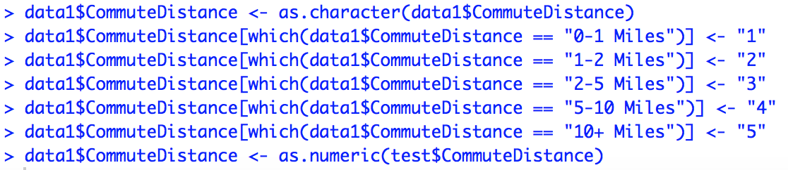

The following shows the commute distance value before and after replacing

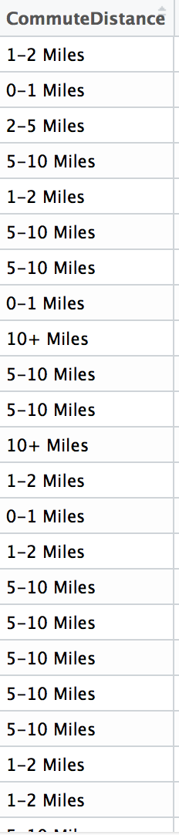 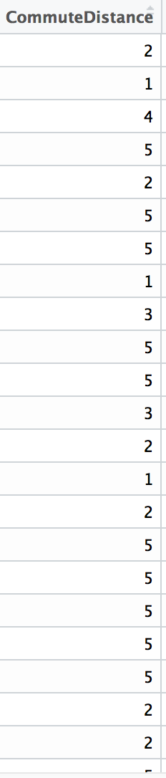

**2-3-2. Barplot of commute distance**

First create frequency table named dist

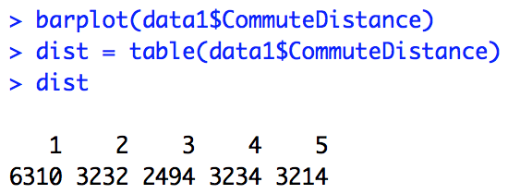

Then plot barplot using the dist table



The barplot is as following:

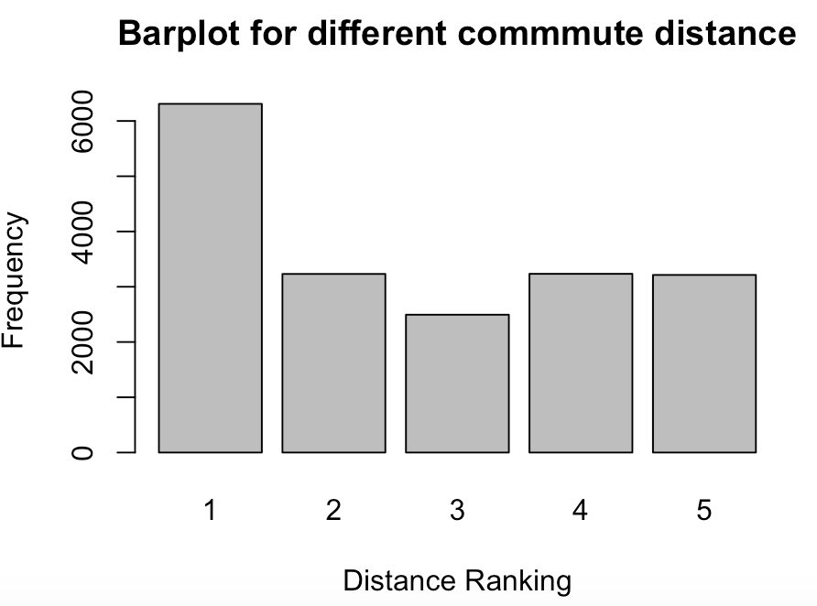

**2-3-3.** **Calculate median, mean, variance and standard deviation for YearlyIncome.**

In R, use summary() to get the 5-number summary values. The min is 1 which is 0-1 miles, max is 5 which

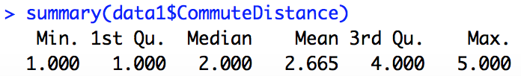

The variance is 2.3 and standard deviation is 1.5.

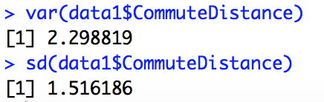

2-4**. HouseOwnerFlag**. It is binary and discrete, the value is 0 (buyer has no house) and 1 (buyer has a house). There is no need to transform data.

**2-4-1. Barplot of houseOwner**. The y value of the plot is scaled into 0-1. First we get the number of house owner in percentage:

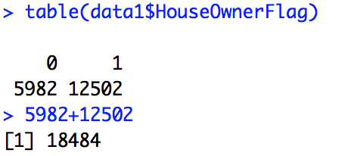

Divide the value with total number and get a table in percent.

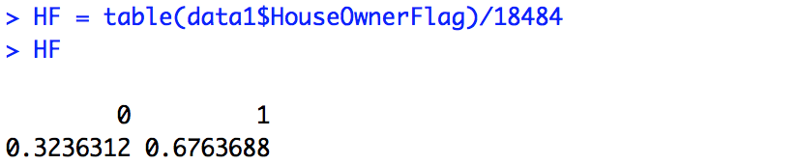

plot barplot for HouseOwnerFlag



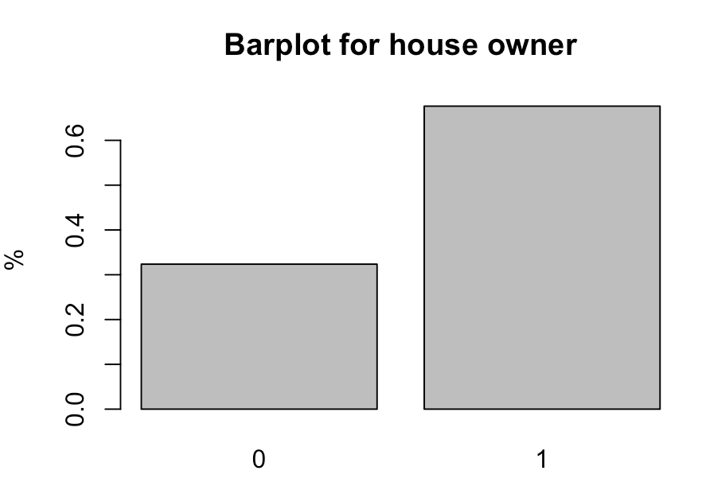

**2-4-2. The 5-number summary, variance and standard deviation.**

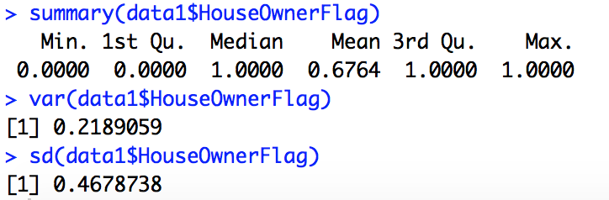

2-5. **NumberCarsOwned**. It is discrete and ratio.

**2-5-1. Barplot. First create frequency table.**

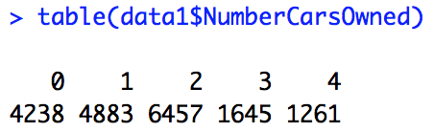

Then use barplot to get the plotting graph



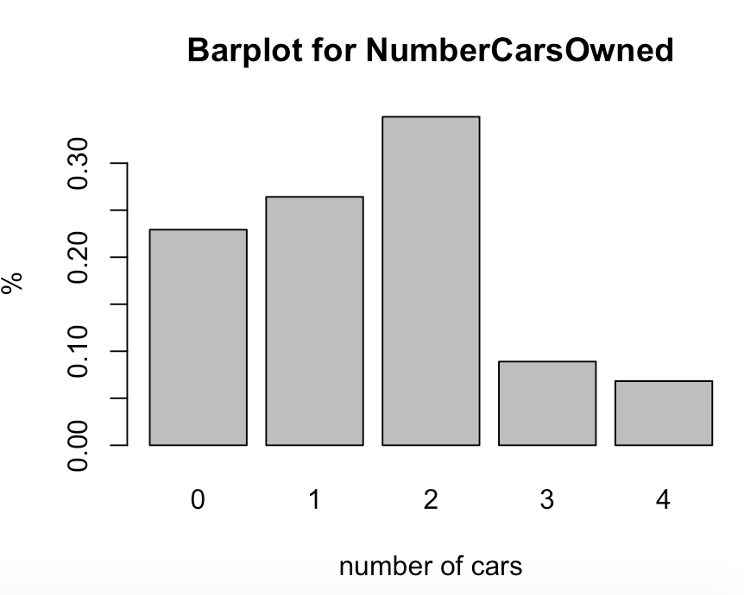

2-5-2. **The 5-number summary, variance and standard deviation.**

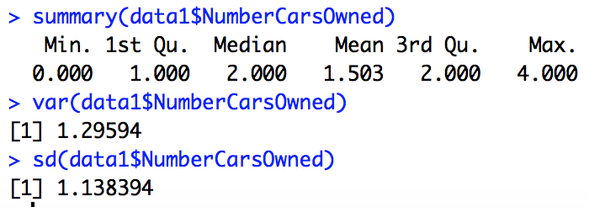

2-6. **NumberChildren at Home**, discrete and ratio, same as NumberCarOwned.

**2-6-1. Barplot**

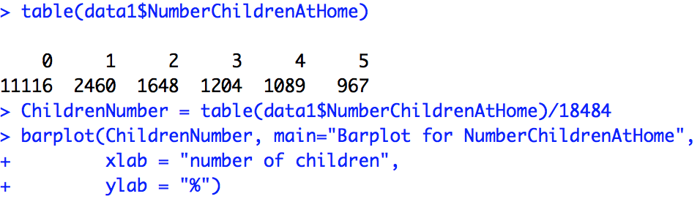

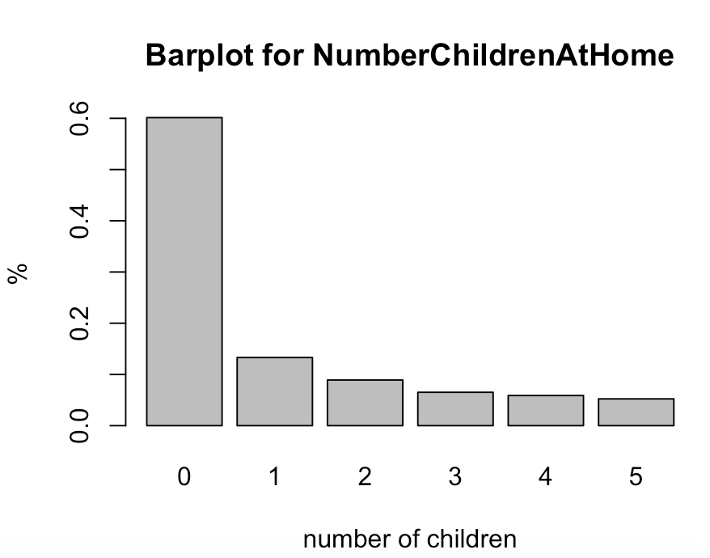

**2-6-2.** **The 5-number summary, variance and standard deviation.**

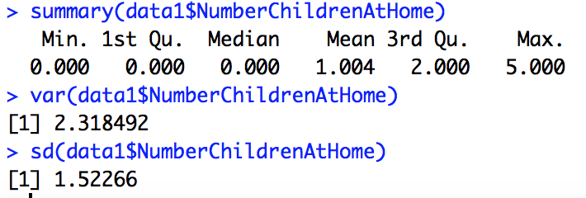

2-7. **Region**. Region is nominal and discrete. I plotted **PieChart**, similar idea as numberCarsOwned, the only different is to use piechart to represent. The frequency was normalized into 0-1.

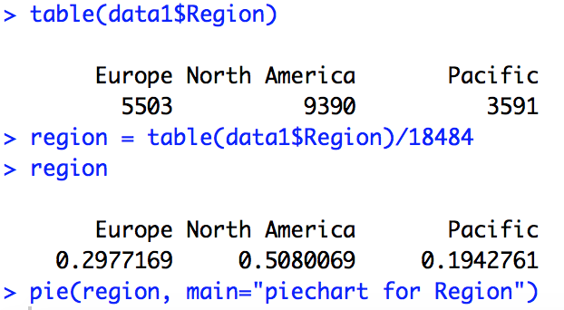

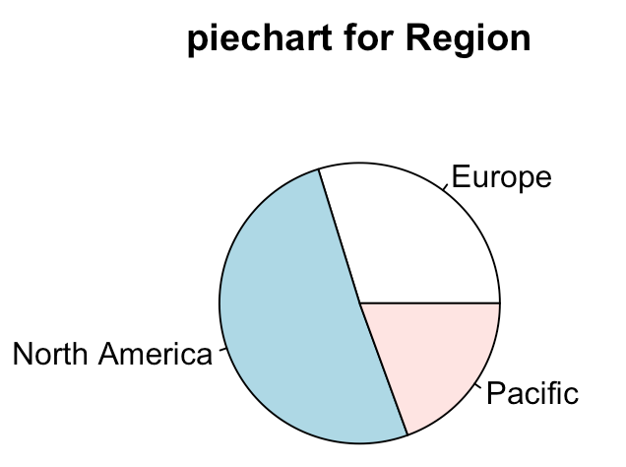

2-8. **EnglishOccupation**. It is nominal and discrete, similar as region.

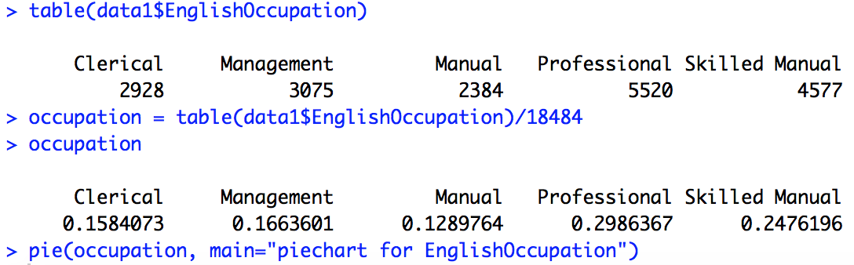

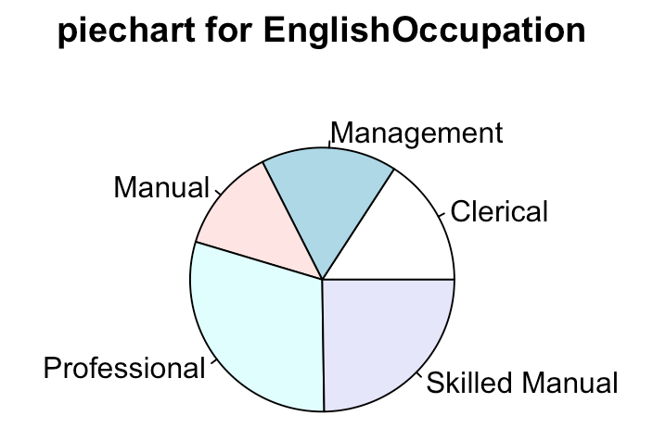

2-9. Summary of mean, median, variance and sd in part2

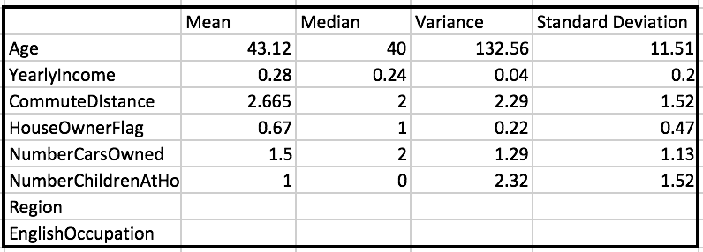

2-10. Export transformed data from R to .txt file.



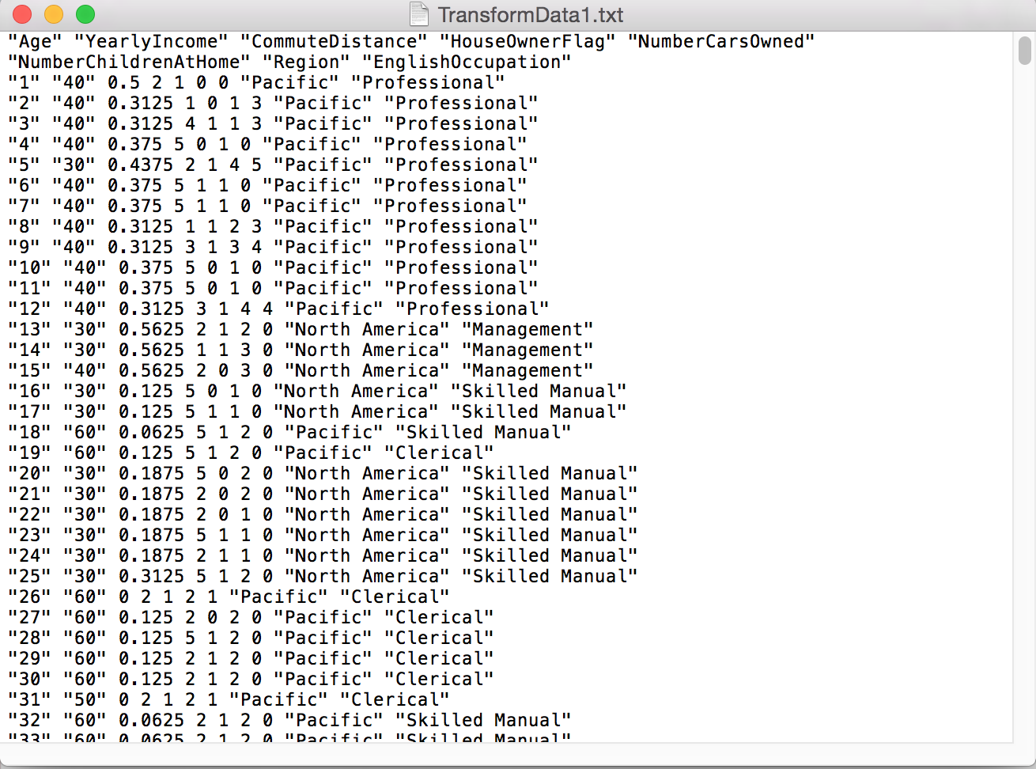

**Part 3. Dissimilarity Calculation**

To calculate the dissimilarity, we need to use different calcalation methods according to the feature type. The 8 attributes are mixed typed, so I choose different method to calculate. I group these attributes into 3 groups for dissimilarity calculation: normalized distance, interval-scaled and binary contigency. Following table shows different method for different feature.

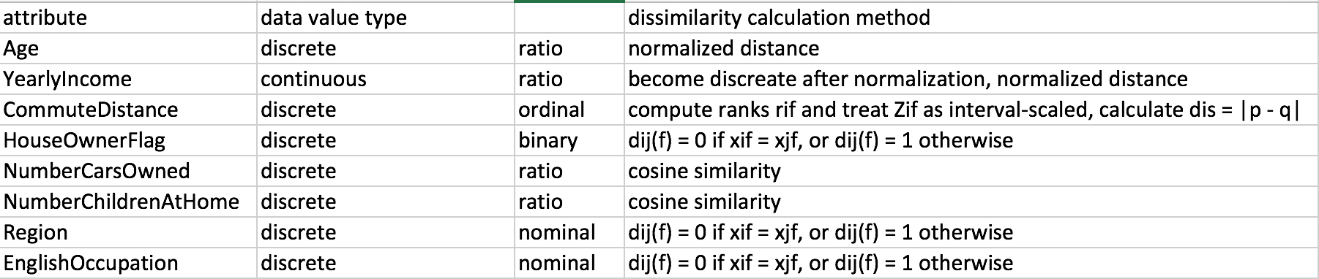

-For CommuteDistance, I use scaled-interval to calculate the scaled data

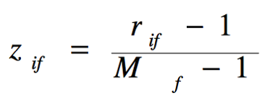 where rif belongs to 1…Mf, then the data will be used to calculate euclidean distance. Then I use 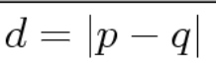to detemine the distance

-For Age and yearlyIncome, I use euclidian distance to calculate dnum

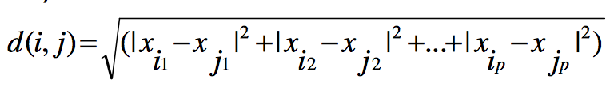

-For HouseOwnerFlag, Region and EnglishOccupation, I use Hamming distance and jaccard distance to calculate dbin

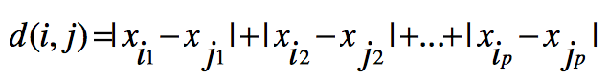

-For NumberCarsOwned, NumberChildrenAtHome, I use cosine distance to calculate discos

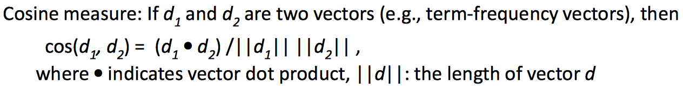

3-1. Euclidean distance

3-1-1. Commute distance scaling. The rank is from 1 to 5, according to the formular above, we could scale the interval to get scaled data zif = (rif - 1)/ (Mf - 1), M = 5

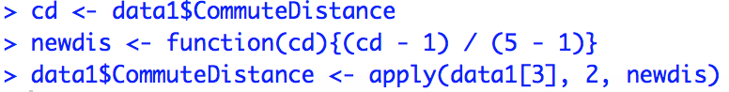

The following shows the data of commute distance before and after

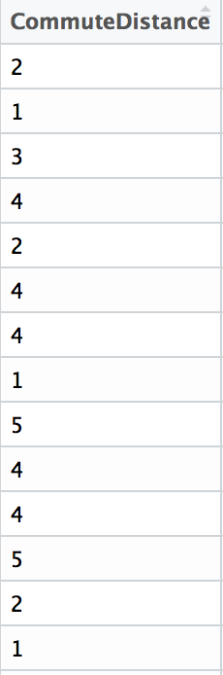 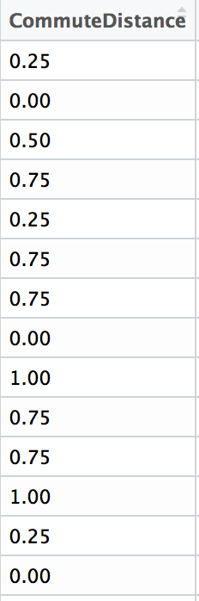

3-1-2. Data sampling

Use sample() function to randomly select 100 rows from the dataset



It has 100 observations (rows) and 8 attributes



Part of the sample data

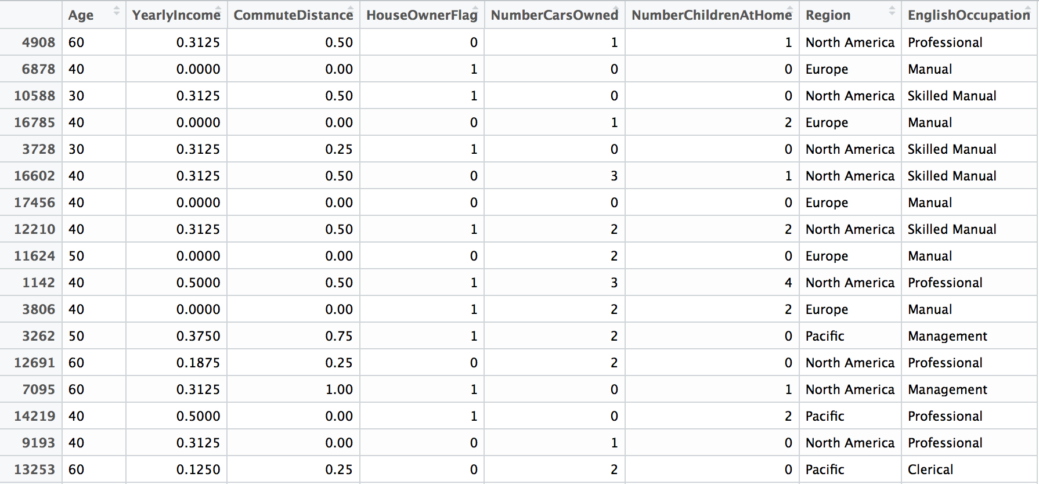

Select the first 3 column (Age, yearly income and commute distance) for calculation

Use sample function to choose 100 sample for euclidean distance measurement.

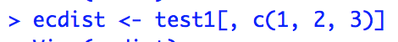



The 100-row sample of data with 3 features:

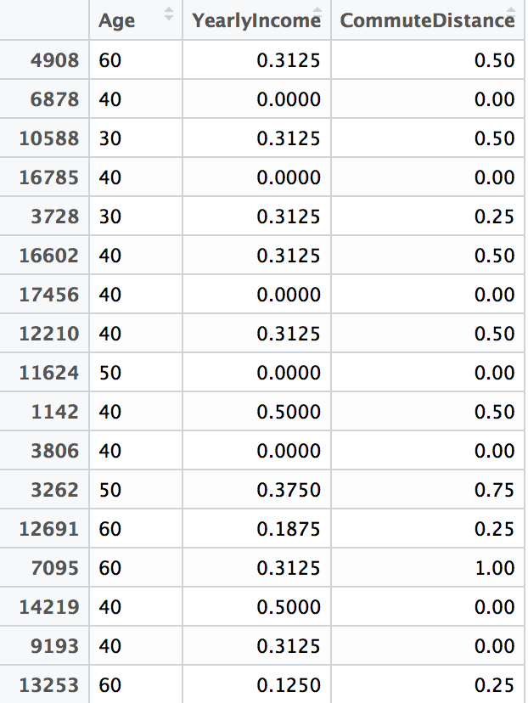

3-1-3. Calculate euclidean distance of Age, yearlyIncome and commuteDistance.

Use funtion ridst(x, y) to calculate euclidean distance, save the result in .txt file

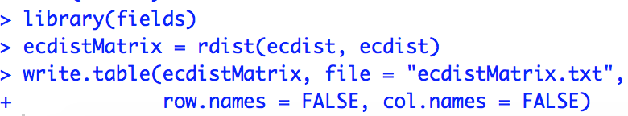

result in txt

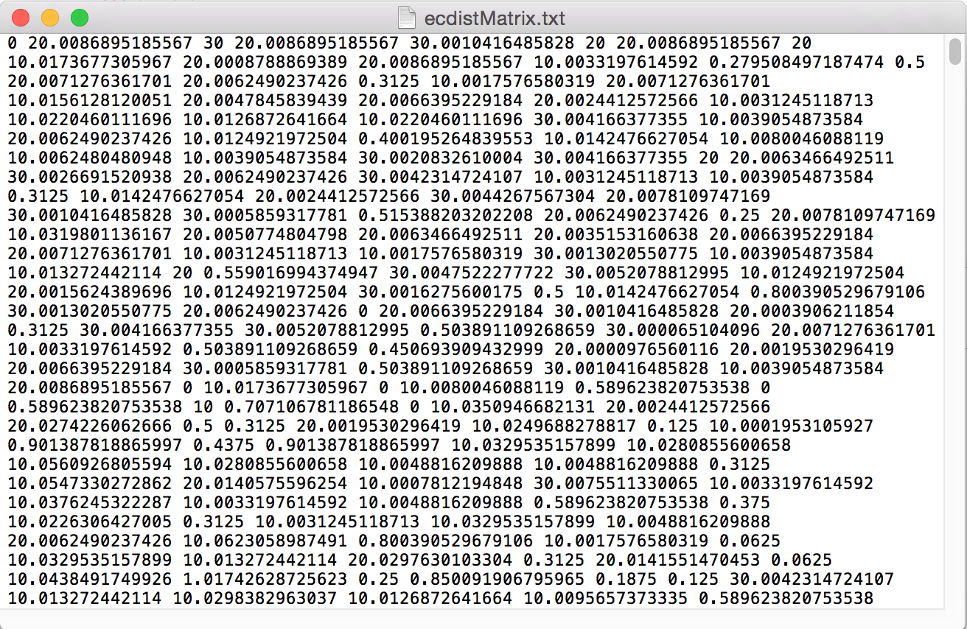

3-2. Hamming distance and jaccard distance

3-2-1. Selecte three features from the sample dataset (test1, size = 100) for hamming and jaccard distance calculation, the three features are Homeownerflag, region and EnglishOccupation.





The selected data are as following:

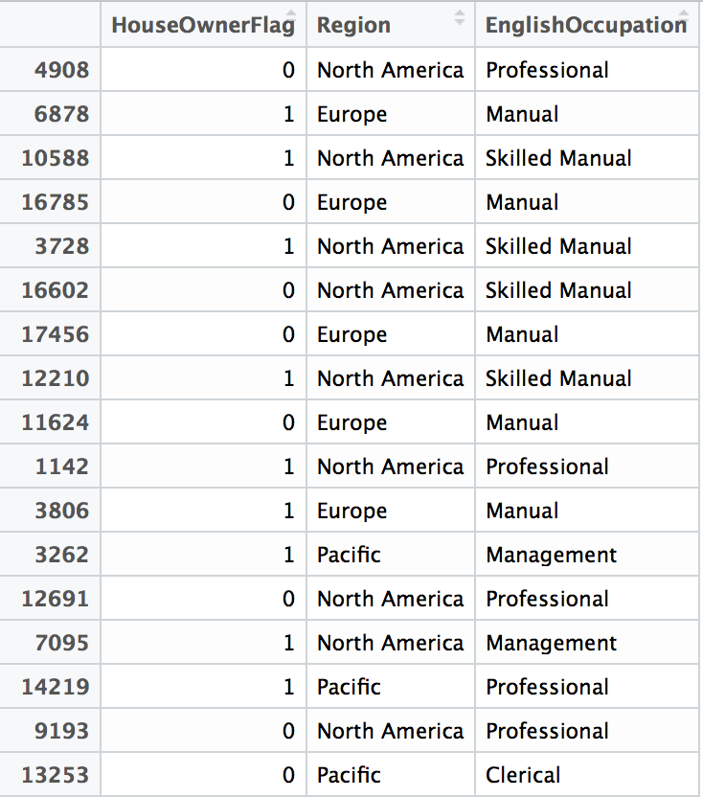

3-2-2. Binarization of attribute Region and EnglishOccupation. There are 3 regions, split the column into 3, and assign 0 or 1 to the new columns. Idea is as following:

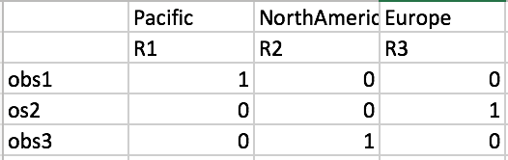

obs1 has a region of pacific, so R1 = 1, R2, R3 = 0.

Same idea for EnglishOccupation

Command for binarazation of Region and EnglishOccupation:

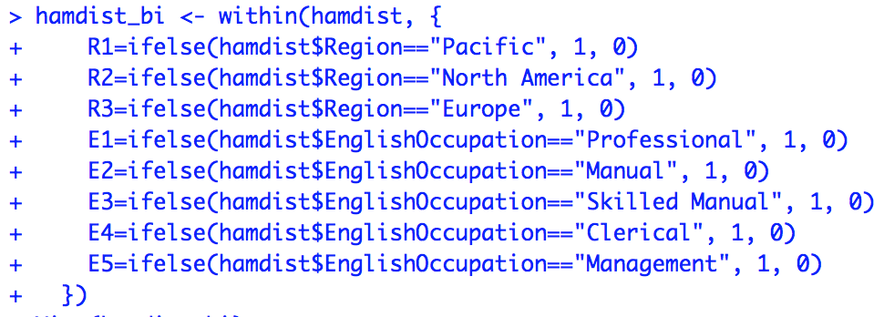

The new dataframe:



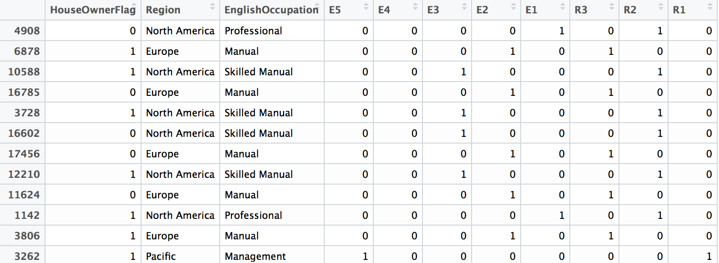

select HouseOwnerFlag, R1-R3, E1-E5 for Hamming distance calculation.





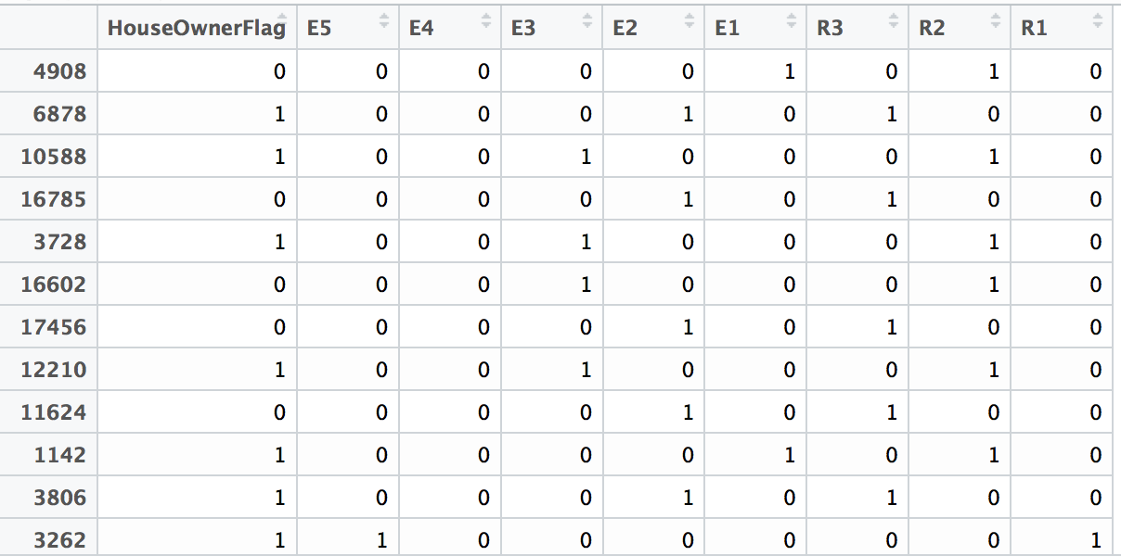

3-2-3. Hamming distance

Calculate hamming distance using dataset hamdist_bical, the result is a 100*100 matrix ranging from 0 – 5 (after binarization, there is only one 1 in R1, R2, R3 and only one 1 in E1 and E2)

Code in R. There are two loops to iterate each pair, and get the count of sum when data[i] != data[j] and save the sum to a matrix.

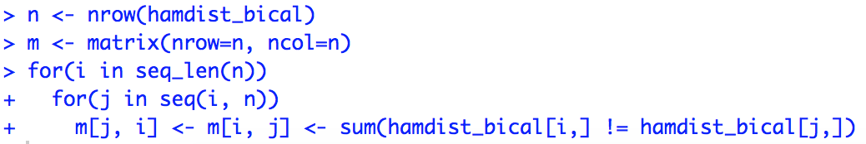

The output matrix m

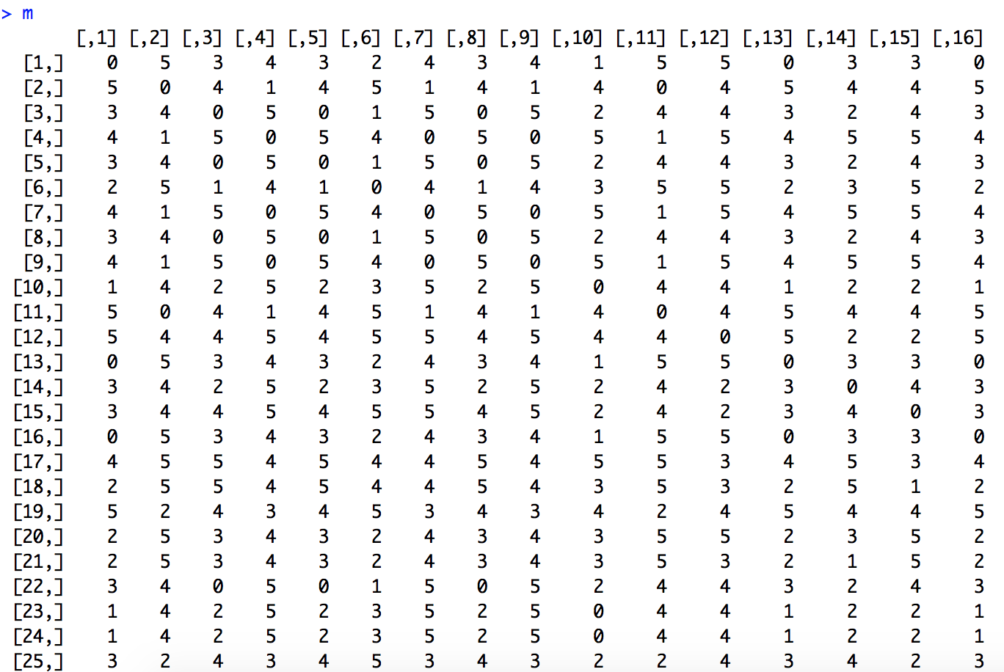

Save the matrix into .txt file named hamdist.txt



3-2-4. Jaccard distance. I use the same dataset hamdist_bical to calculate the Jaccard diatance.

For asymetric binary variables, the formular is as following:

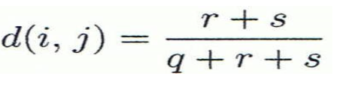

according to the contengency table

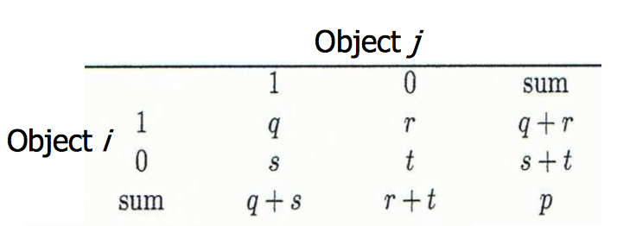

r + s = hamming distance, q is the count when both i and j equal 1.

R code for calculating jaccard distance. There are two for loop to iterate each pair, rs is the sum of count when data[i] != data[j], q is the summation of count when data[i] == 1 and data[j] == 1. Then I use the formula (dis jaccard = (r + s ) / (r + s + q)) to get the jacdis.

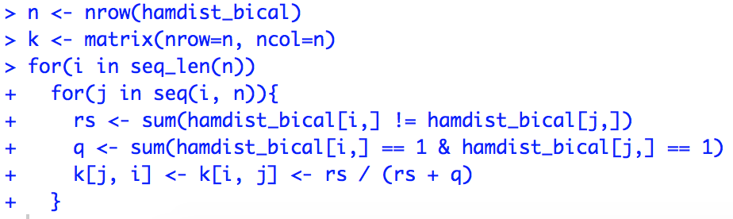

save the output the .txt file named jacdist.txt



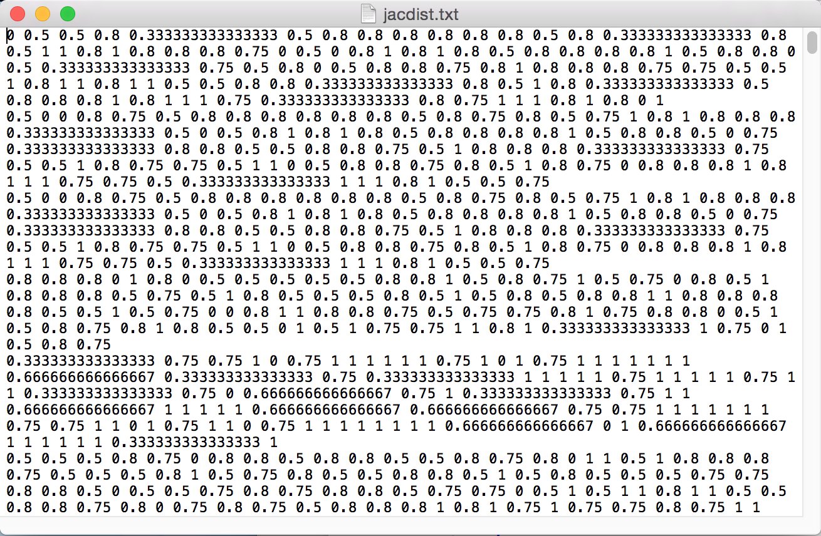

3-2-5. Jaccard Similarity

simjaccard = 1 - disjaccard . The matrix was saved in jacsim.txt.

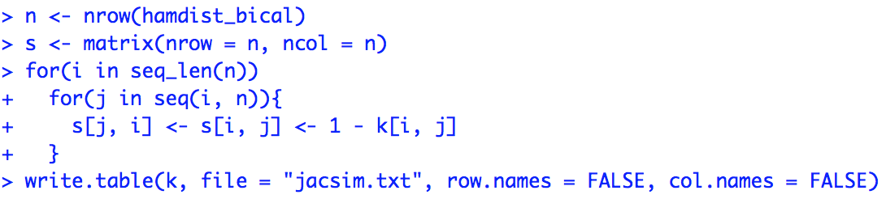

3-3. Cosine Similarity

3-3-1. The attributes NumberCarsOwned and NumberChildrenAtHome should use cosine similarity to calculate the similarity. First extract data of the two attributes from sample data.





The sample data for calculating looks like this

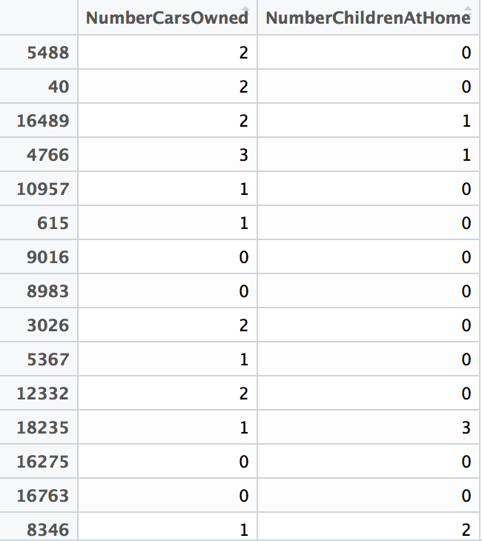

3-3-2. calculating cosine similarity. I used the library proxy to calculate the cosine similarity, the formular used is 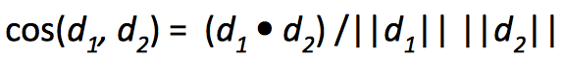

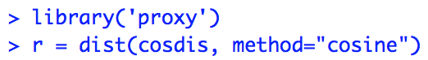



Appendix

Java code

mean

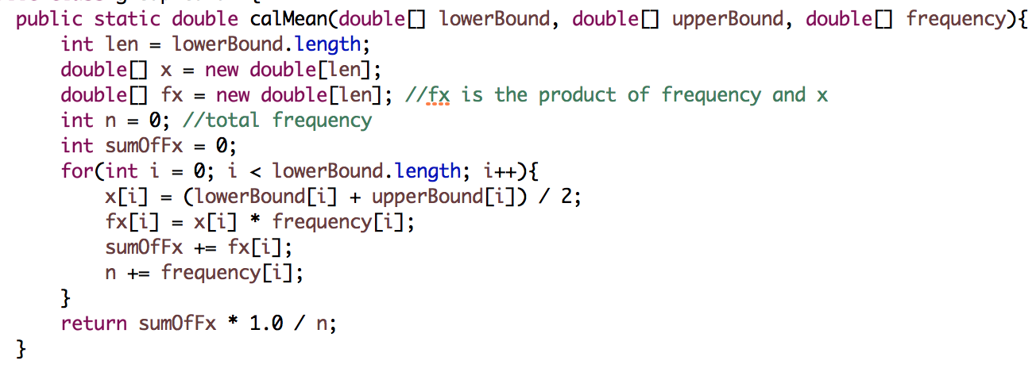

median

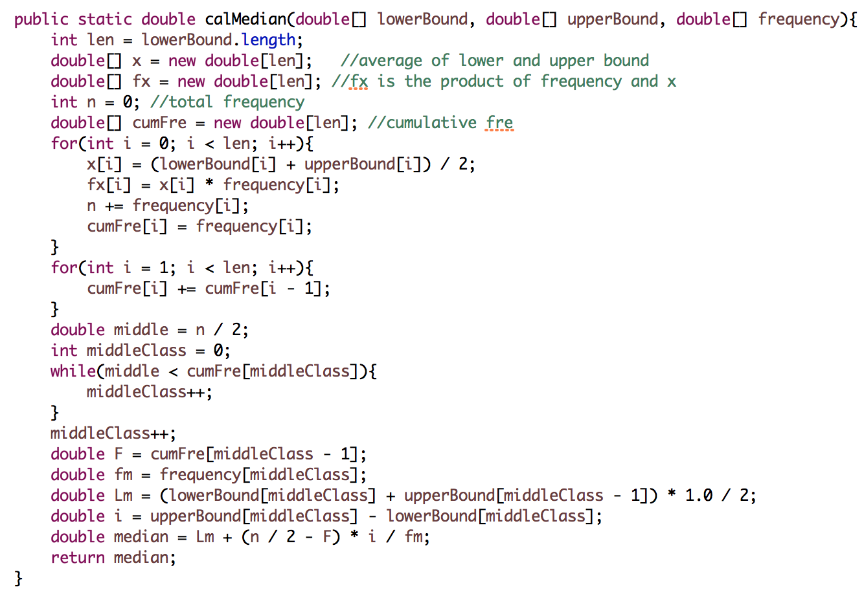

variance

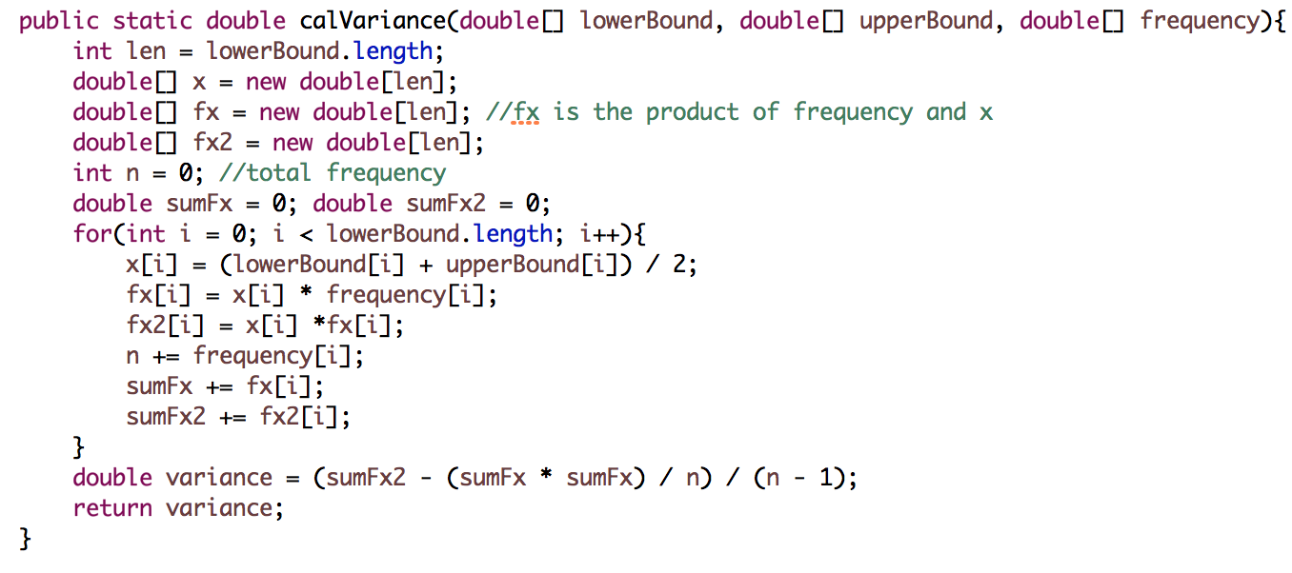

standard deviation

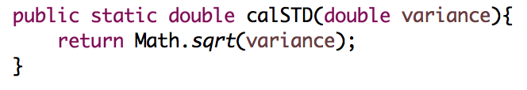

main

